Project Report

***Submitted by***

***Md Bayzed Bostami***

***Batch:44***

***University of Barishal***



***Roll:13***

***Submitted to***

***Md. Erfan***

***Assistant Professor &Chairman***

***Department of CSE***

Contents

1 Introduction 3

2 Key points of (UDHR) 4

2.1 Main article: History of human rights 5

3 Creation and drafting 5

3.1 Main article: Drafting of the Universal Declaration of Human Rights 5

4 International Human Rights Day 6

4.1 Main article: Human Rights Day 6

4.2 Significance 7

4.3 Legal effect 7

4.4 National law 8

5 Reaction 9

5.1 Praise and support 9

6 Criticism 10

6.1 Muslim-majority countries 10

6.1.1 Professor of Law and Political Science at the International University of Rabat in Morocco, has stated: 10

6.2 The Right to Refuse to Kill 11

6.3 American Anthropological Association 11

6.4 Bangkok Declaration 11

7 Conclusion 12

8 References 12

**Universal Declaration of Human Rights (UDHR)**

# Introduction

The Universal Declaration of Human Rights (UDHR) is an international document adopted by the United Nations General Assembly that enshrines the rights and freedoms of all human beings. Drafted by a UN committee chaired by Eleanor Roosevelt, it was accepted by the General Assembly as Resolution 217 during its third session on 10 December 1948 at the Palais de Chaillot in Paris, France. Of the 58 members of the United Nations at the time, 48 voted in favour, none against, eight abstained, and two did not vote. A foundational text in the history of human and civil rights, the Declaration consists of 30 articles detailing an individual's "basic rights and fundamental freedoms" and affirming their universal character as inherent, inalienable, and applicable to all human beings. Adopted as a "common standard of achievement for all peoples and all nations", the UDHR commits nations to recognize all humans as being "born free and equal in dignity and rights" regardless of "nationality, place of residence, gender, national or ethnic origin, colour, religion, language, or any other status".The Declaration is considered a "milestone document" for its "universalist language", which makes no reference to a particular culture, political system, or religion. It directly inspired the development of international human rights law, and was the first step in the formulation of the International Bill of Human Rights, which was completed in 1966 and came into force in 1976. Although not legally binding, the contents of the UDHR have been elaborated and incorporated into subsequent international treaties, regional human rights instruments, and national constitutions and legal codes. All 193 member states of the United Nations have ratified at least one of the nine binding treaties influenced by the Declaration, with the vast majority ratifying four or more. While there is a wide consensus that the declaration itself is non-binding and not part of customary international law, there is also a consensus that many of its provisions are binding and have passed into customary international law, although courts in some nations have been more restrictive on its legal effect. Nevertheless, the UDHR has influenced legal, political, and social developments on both the global and national levels, with its significance partly evidenced by its 530 translations, the most of any document in history.

# Key points of (UDHR)

The underlying structure of the Universal Declaration was influenced by the Code Napoléon, including a preamble and introductory general principles. Its final structure took form in the second draft prepared by French jurist René Cassin, who worked on the initial draft prepared by Canadian legal scholar John Peters Humphrey. The preamble sets out the historical and social causes that led to the necessity of drafting the Declaration.

Articles 1–2 establish the basic concepts of dignity, liberty, and equality.

Articles 3–5 establish other individual rights, such as the right to life and the prohibition of slavery and torture.

Articles 6–11 refer to the fundamental legality of human rights with specific remedies cited for their defence when violated.

Articles 12–17 set forth the rights of the individual towards the community, including freedom of movement and residence within each state, the right of property and the right to a nationality.

Articles 18–21 sanction the so-called "constitutional liberties" and spiritual, public, and political freedoms, such as freedom of thought, opinion, expression, religion and conscience, word, peaceful association of the individual, and receiving and imparting information and ideas through any media.

Articles 22–27 sanction an individual's economic, social and cultural rights, including healthcare. It upholds an expansive right to an adequate standard of living, and makes special mention of care given to those in motherhood or childhood.

Articles 28–30 establish the general means of exercising these rights, the areas in which the rights of the individual cannot be applied, the duty of the individual to society, and the prohibition of the use of rights in contravention of the purposes of the United Nations Organization.

Cassin compared the Declaration to the portico of a Greek temple, with a foundation, steps, four columns, and a pediment. Articles 1 and 2—with their principles of dignity, liberty, equality and brotherhood—served as the foundation blocks. The seven paragraphs of the preamble, setting out the reasons for the Declaration, represent the steps leading up to the temple. The main body of the Declaration forms the four columns. The first column (articles 3–11) constitutes rights of the individual, such as the right to life and the prohibition of slavery. The second column (articles 12–17) constitutes the rights of the individual in civil and political society. The third column (articles 18–21) is concerned with spiritual, public, and political freedoms, such as freedom of religion and freedom of association. The fourth column (articles 22–27) sets out social, economic, and cultural rights. Finally, the last three articles provide the pediment which binds the structure together, as they emphasize the mutual duties of every individual to one another and to society.

## Main article: History of human rights

State of the Union (Four Freedoms) (6 January 1941)

Franklin Delano Roosevelt's 6 January 1941 State of the Union address introducing the theme of the Four Freedoms (starting at 32:02) Problems playing this file? See media help. During World War II, the Allies—known formally as the United Nations—adopted as their basic war aims the Four Freedoms: freedom of speech, freedom of religion, freedom from fear, and freedom from want. the end of the war, the United Nations Charter was debated, drafted, and ratified to reaffirm "faith in fundamental human rights, and dignity and worth of the human person" and commit all member states to promote "universal respect for, and observance of, human rights and fundamental freedoms for all without distinction as to race, sex, language, or religion". When the atrocities committed by Nazi Germany became fully apparent after the war, the consensus within the world community was that the UN Charter did not sufficiently define the rights to which it referred.[20][21] It was deemed necessary to create a universal declaration that specified the rights of individuals so as to give effect to the Charter's provisions on human rights.

# Creation and drafting

## Main article: Drafting of the Universal Declaration of Human Rights

In June 1946, the Economic and Social Council (ECOSOC)—a principal organ of the newly founded United Nations responsible for promoting human rights—created the Commission on Human Rights (CHR), a standing body within the United Nations tasked with preparing what was initially conceived as an International Bill of Rights. It had 18 members from various national, religious, and political backgrounds, so as to be representative of humanity. In February 1947, the Commission established a special Universal Declaration of Human Rights Drafting Committee, chaired by Eleanor Roosevelt of the United States, to write the articles of the Declaration. Roosevelt, in her position, was key to the U.S. effort to encourage the General Assembly’s adoption of a Universal Declaration of Human Rights .The Committee met in two sessions over the course of two years.

Canadian John Peters Humphrey, the newly appointed Director of the Division of Human Rights within the United Nations Secretariat, was called upon by the UN Secretary-General to work on the project, becoming the Declaration's principal drafter Other prominent members of the Drafting Committee included Vice-Chairman P.C. Chang of the Republic of China, René Cassin of France; and its Committee Rapporteur Charles Malik of Lebanon. A month after its creation, the Drafting Committee was expanded to include representatives of Australia, Chile, France, the Soviet Union, and the United Kingdom, in addition to the inaugural members from China, France, Lebanon, and the United States.

Voting in the plenary session.

Green countries: voted in favour.

Orange countries: abstained.

Black countries: failed to abstain or vote.

Grey countries: were not part of the UN at time of voting.

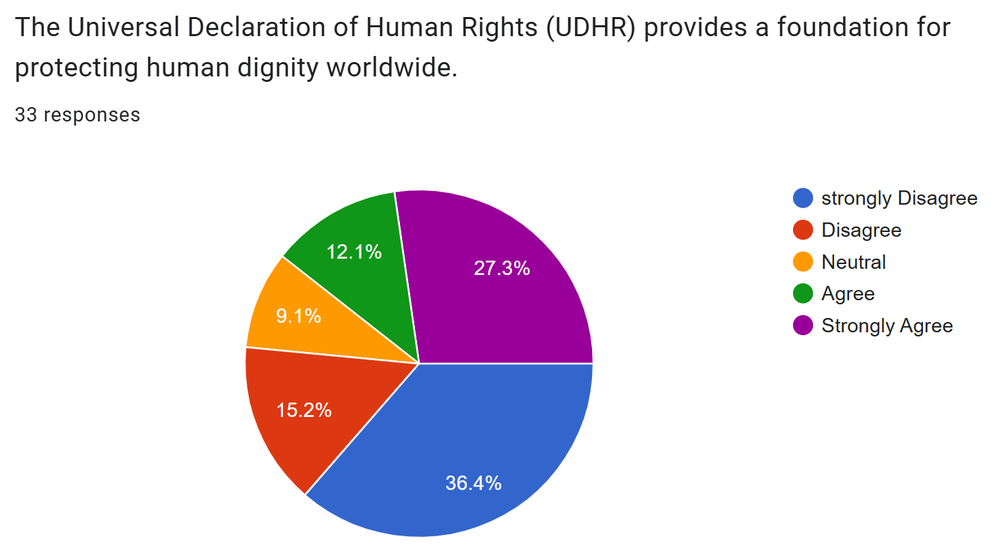

# International Human Rights Day

Former-Foreign Office Minister Baroness Anelay speaking at the Commemorating Human Rights Day event in London, 8 December 2016.

## Main article: Human Rights Day

10 December, the anniversary of the adoption of the Universal Declaration, is celebrated annually as World Human Rights Day or International Human Rights Day. The commemoration is observed by individuals, community and religious groups, human rights organizations, parliaments, governments, and the United Nations. Decadal commemorations are often accompanied by campaigns to promote awareness of the Declaration and of human rights in general. 2008 marked the 60th anniversary of the Declaration, and was accompanied by year-long activities around the theme "Dignity and justice for all of us". Likewise, the 70th anniversary in 2018 was marked by the global #StandUpForHumanRights campaign, which targeted youth.

## Significance

At the time of the Declaration's adoption by the General Assembly in 1948, Eleanor Roosevelt said; In giving our approval to the declaration today, it is of primary importance that we keep clearly in mind the basic character of the document. It is not a treaty; it is not an international agreement. It is not and does not purport to be a statement of law or of legal obligation. It is a declaration of basic principles of human rights and freedoms, to be stamped with the approval of the General Assembly by formal vote of its members, and to serve as a common standard of achievement for all peoples of all nations.

The UDHR is considered groundbreaking for providing a comprehensive and universal set of principles in a secular, apolitical document that explicitly transcends cultures, religions, legal systems, and political ideologies. Its claim to universality has been described as "boundlessly idealistic" and the "most ambitious feature". The Declaration was officially adopted as a bilingual document in English and French, with official translations in Chinese, Russian and Spanish, all of which are official working languages of the UN. Due to its inherently universalist nature, the United Nations has made a concerted effort to translate the document into as many languages as possible, in collaboration with private and public entities and individuals. In 1999, the Guinness Book of Records described the Declaration as the world's "Most Translated Document

## Legal effect

In international law, a declaration is distinct from a treaty in that it generally states aspirations or understandings among the parties, rather than binding obligations. The Declaration was explicitly adopted to reflect and elaborate on the customary international law reflected in the "fundamental freedoms" and "human rights" referenced in the United Nations Charter, which is binding on all member states. For this reason, the Universal Declaration of Human Rights is a fundamental constitutive document of the United Nations and, by extension, all 193 parties of the United Nations Charter.Nevertheless, the status of the Declaration as a legally enforceable document varies widely around the world: some countries have incorporated it into their domestic laws, while other countries consider it merely a statement of ideals, with no binding provisions.

Many international lawyers believe that the Declaration forms part of customary international law and is a powerful tool in applying diplomatic and moral pressure to governments that violate its articlesOne prominent international jurist described the UDHR as being "universally regarded as expounding generally accepted norms." Other legal scholars have further argued that the Declaration constitutes jus cogens,

## National law

According to a 2022 study, the UDHR "significantly accelerated the adoption of a particular set of [national] constitutional rights." One scholar estimates that at least 90 national constitutions drafted since the Declaration's adoption in 1948 "contain statements of fundamental rights which, where they do not faithfully reproduce the provisions of the Universal Declaration, are at least inspired by it." At least 20 African nations that attained independence in the decades immediately following 1948 explicitly referenced the UDHR in their constitutions. As of 2014, the constitutions that still directly cite the Declaration are those of Afghanistan, Benin, Bosnia-Herzegovina, Burkina Faso, Burundi, Cambodia, Chad, Comoros, Côte d'Ivoire, Equatorial Guinea, Ethiopia, Democratic Republic of the Congo, Gabon, Guinea, Haiti, Mali, Mauritania, Nicaragua, Niger, Portugal, Romania, Rwanda, São Tomé and Príncipe, Senegal, Somalia, Spain, Togo, and Yemen. Moreover, the constitutions of Portugal, Romania, São Tomé and Príncipe, and Spain compel their courts to "interpret" constitutional norms consistently with the Universal Declaration.

Judicial and political figures in many nations have directly invoked the UDHR as an influence or inspiration on their courts, constitutions, or legal codes. Indian courts have ruled the Indian Constitution "[embodies] most of the articles contained in the Declaration". Nations as diverse as Antigua, Chad, Chile, Kazakhstan, Saint Vincent and the Grenadines, and Zimbabwe have derived constitutional and legal provisions from the Declaration. In some cases, specific provisions of the UDHR are incorporated or otherwise reflected in national law. The right to health or to protection of health is found in the constitutions of Belgium, Kyrgyzstan, Paraguay, Peru, Thailand, and Togo; constitutional obligations on the government to provide health services exist in Armenia, Cambodia, Ethiopia, Finland, South Korea, Kyrgyzstan, Paraguay, Thailand, and Yemen.

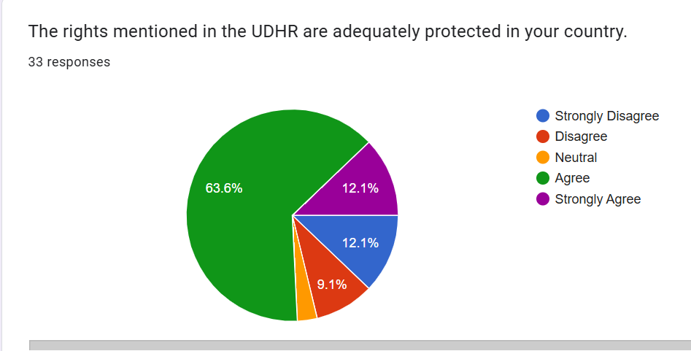

# Reaction

## Praise and support

The Universal Declaration has received praise from a number of notable activists, jurists, and political leaders. Lebanese philosopher and diplomat Charles Malik called it "an international document of the first order of importance", while Eleanor Roosevelt—first chairperson of the Commission on Human Rights (CHR) that helped draft the Declaration—stated that it "may well become the international Magna Carta of all men everywhere." At the 1993 United Nations World Conference on Human Rights, one of the largest international gatherings on human rights, diplomats and officials representing 100 nations reaffirmed their governments' "commitment to the purposes and principles contained in the Charter of the United Nations and the Universal Declaration of Human Rights" and emphasized that the Declaration as "the source of inspiration and has been the basis for the United Nations in making advances in standard setting as contained in the existing international human rights instruments." In a speech on 5 October 1995, Pope John Paul II called the Declaration "one of the highest expressions of the human conscience of our time", despite the Vatican never adopting it. In a statement on 10 December 2003 on behalf of the European Union, Marcello Spatafora said that the Declaration "placed human rights at the centre of the framework of principles and obligations shaping relations within the international community".

As a pillar of international human rights, the UDHR enjoys widespread support among international and nongovernmental organizations. The International Federation for Human Rights (FIDH), one of the oldest human rights organizations, has as its core mandate the promotion of the respect for all rights set out in the Declaration, the International Covenant on Civil and Political Rights, and the International Covenant on Economic, Social and Cultural Rights.Amnesty International, the third oldest international human rights organization, has regularly observed Human Rights Day and organized worldwide events to bring awareness and support of the UDHR. Some organizations, such as the Quaker United Nations Office, the American Friends Service Committee, and Youth for Human Rights International (YHRI) have developed curriculum or programmes to educate young people on the UDHR.

# Criticism

## Muslim-majority countries

Further information: Cairo Declaration of Human Rights in Islam Distribution map of Islam by country Most Muslim-majority countries that were then members of the United Nations signed the Declaration in 1948, including the kingdoms of Afghanistan, Egypt, and Iraq, Pahlavi Iran, and the First Syrian Republic; the Republic of Turkey, which had an overwhelmingly Muslim population but an officially secular government, also voted in favour. Saudi Arabia was the sole abstainer on the Declaration among Muslim-majority countries, claiming that it violated the Islamic law (sharīʿa). Pakistan, officially an Islamic state, signed the declaration and critiqued the Saudi position, strongly arguing in favour of including freedom of religion as a fundamental human right of the UDHR.

### Professor of Law and Political Science at the International University of Rabat in Morocco, has stated:

the twenty-two-member League of Arab States (Arab League)—each of whose members also belongs to the OIC and is majority-Muslim—created its own human rights instruments and institutions (based in Cairo) that set it apart from the international human rights regime. While the term "Arab" denotes an ethnicity and "Muslim" references a religion, all majority-Arab countries are also majority-Muslim countries, though the opposite does not hold. Indeed, the preponderance of Muslim-majority countries is not Arab. It has long been recognized that the Muslim-majority Arab world ranks particularly poorly with respect to human rights. According to the 2009 Arab Human Development Report, written by Arab experts for the United Nations Development Program Regional Bureau for Arab States, "Arab states seem content to ratify certain international human rights treaties, but do not go so far as to recognize the role of international mechanisms in making human rights effective." The resistance to implementation of international human rights standards in parts of the Muslim and Arab worlds is perhaps most salient with the panoply of rights related to religion. In terms of the UDHR, the core of the resistance is centered on issues of the right to freedom of thought, conscience, and religion (Article 18), prohibition of discrimination on the basis of religion (Article 2), and the prohibition of discrimination against women (preamble, Article 2, Article 16). The same resistance to universal standards, already present in the UDHR, continued in subsequent elaborations of human rights, including the International Covenant on Civil and Political Rights (ICCPR), the Convention on the Elimination of All Forms of Discrimination Againest Women.

## The Right to Refuse to Kill

Groups such as Amnesty International and War Resisters International have advocated for "The Right to Refuse to Kill" to be added to the Universal Declaration, as has Seán MacBride, a former Assistant Secretary-General of the United Nations and Nobel Peace Prize laureate. War Resisters International has stated that the right to conscientious objection to military service is primarily derived from Article 18 of the UDHR, which preserves the right to freedom of thought, conscience, and religion. Some steps have been taken within the UN to make the right more explicit, with the Human Rights Council repeatedly affirming that Article 18 enshrines "the right of everyone to have conscientious objection to military service as a legitimate exercise of the right to freedom of thought, conscience and religion".

## American Anthropological Association

The American Anthropological Association criticized the UDHR during its drafting process, warning that its definition of universal rights reflected a Western paradigm that was unfair to non-Western nations. They further argued that the West's history of colonialism and evangelism made them a problematic moral representative for the rest of the world. They proposed three notes for consideration with underlying themes of cultural relativism:

The individual realizes his personality through his culture, hence respect for individual differences entails a respect for cultural differences. Respect for differences between cultures is validated by the scientific fact that no technique of qualitatively evaluating cultures has been discovered. Standards and values are relative to the culture from which they derive so that any attempt to formulate postulates that grow out of the beliefs or moral codes of one culture must to that extent detract from the applicability of any Declaration of Human Rights to mankind as a whole.

## Bangkok Declaration

During the lead up to the World Conference on Human Rights held in 1993, ministers from several Asian states adopted the Bangkok Declaration, reaffirming their governments' commitment to the principles of the United Nations Charter and the Universal Declaration of Human Rights. They stated their view of the interdependence and indivisibility of human rights and stressed the need for universality, objectivity, and non-selectivity of human rights. However, at the same time, they emphasized the principles of sovereignty and non-interference, calling for greater emphasis on economic, social, and cultural rights—in particular.

# Conclusion

The human rights ideal proclaimed in the Universal Declaration of Human Rights was ignited and has been kept lit by great human beings. As the advancement of the liberating power of human rights deeply depends on their being rooted in hearts, minds and everyday life, human rights education should be of paramount concern. The ‘mothers and fathers’ of the 1948 Universal Declaration were aware that the promotion and protection of human rights should begin… at the beginning, i.e. with education. Human rights education especially concerns two professional fields: Law and Education. Human beings are, under and above all, their values and sentiments. Human rights education—understood according to its contemporary comprehensive, holistic scope—is an ethical, civic and international education that is crucial for contemporary societies and the survival and perfecting of Humankind.

# References

Buchanan, A. (2000). Human rights and the Universal Declaration of Human Rights. In Human rights: The political and philosophical debate (pp. 55-80). Oxford University Press.

Cassese, A. (2005). International law (2nd ed.). Oxford University Press.

Donnelly, J. (2013). Universal human rights in theory and practice (3rd ed.). Cornell University Press.

Fitzpatrick, J. (2019). Human rights and the global south. Oxford University Press.

Hoffman, S. (2016). The international human rights regime and the Universal Declaration. In International politics: The roles of international organizations (pp. 182-199). Routledge.

Hunt, M. (2007). The United Nations and the Universal Declaration of Human Rights. World Affairs, 169(3), 35-45.

Morsink, J. (1999). The Universal Declaration of Human Rights: Origins, drafting, and intent. University of Pennsylvania Press.

Sachs, A. (2009). The Universal Declaration of Human Rights: A new global order. Cambridge University Press.

United Nations. (1948). Universal Declaration of Human Rights. Retrieved from <https://www.un.org/en/universal-declaration-human-rights>

Vasak, K. (1977). The international protection of human rights: The Universal Declaration of Human Rights and the International Covenant on Civil and Political Rights. UNESCO.